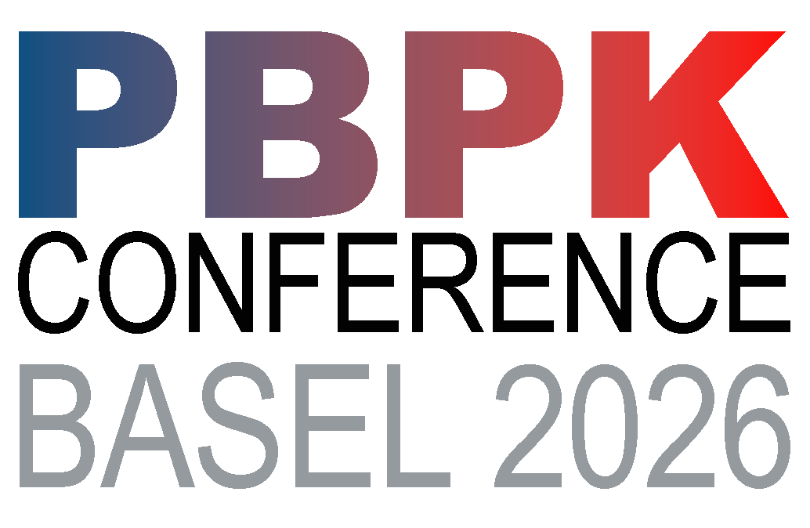
This conference is organized by the International PBPK Nexus

First International PBPK Conference
Program

21-24 April 2026
Novartis Campus - Basel, Switzerland
Fabrikstrasse 15 Frank O. Gehry

- Novartis Campus Map - Inside Our Campus | Novartis Campus
- Pre Conference Workshops: https://pbpkconference.org/pre-conference-workshops/

First International PBPK Conference
Dear Colleagues, Guests, and Friends,
It is our great pleasure to welcome you to the First International PBPK Conference. We are delighted to bring together researchers, clinicians, regulators, industry professionals, and students from around the world to celebrate and advance the science and application of Physiologically Based Pharmacokinetic (PBPK) modelling.
This inaugural meeting marks an important milestone for our community. PBPK has rapidly evolved into a powerful framework supporting drug development, regulatory decision making, risk assessment, and translational research. By convening here, we aim to foster meaningful scientific exchange, highlight emerging innovations, and strengthen the collaborative networks that will drive the next generation of breakthroughs.
Over the coming days, you will hear from distinguished speakers, engage in hands-on discussions, and connect with experts representing a diverse range of disciplines. We encourage you to participate fully—ask questions, share insights, and forge new partnerships. Your contributions are what will make this conference both impactful and memorable.
On behalf of the Organising Committee, thank you for joining us and helping to shape this exciting new chapter for PBPK science. We wish you an inspiring, productive, and enjoyable conference experience.
Warm regards,
The Organising Committee
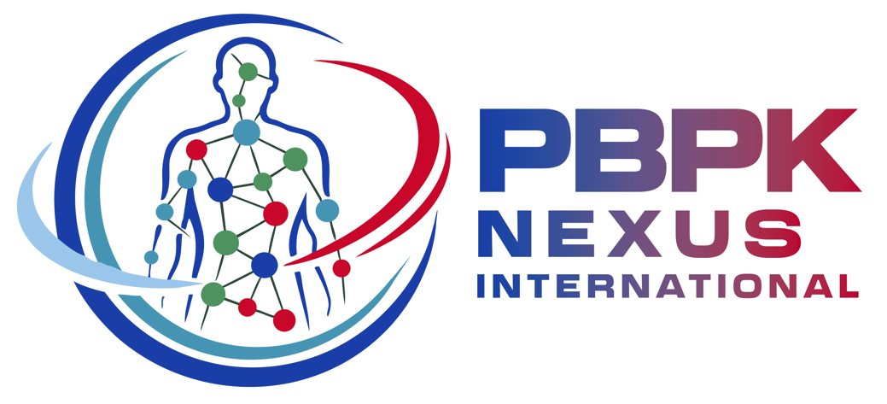

Tuesday 21st April

17:30 Registration & Poster Setup

18:00 Welcome Apero & Networking

Wednesday 22nd April

08:45 Welcome to the First International PBPK Conference
Ioannis Loisios-Konstantinidis, Novartis

PBPK: past, present and future
Session Chairs: Ioannis Loisios-Konstantinidis, Novartis & Stephan Schaller, ESQLabs

09:00 Session Introduction

09:10 Aligning PBPK, Patients and R&D to Create a Common Future
Thierry Lave, Independent Consultant

09:30 PBPK: Did a Knock Down in Round 1; What to Expect for Round 2?
Amin Rostami, University of Manchester

09:50 Bridging PBPK and biological networks for integrated QSP models
Lars Kuepfer, Aachen University

10:10 Q/A

10:30 -11:00 Refreshment break & poster viewing

Drug-Drug Interactions
Session Chairs: Youssef Daali, Geneva University Hospital & Kenichi Umehara, Roche

11:00 Session Introduction

11:10 Savolitinib PBPK Informed by human ADME and In vitro data clarified its Major Elimination Pathway and enabled DDIs prediction
Pradeep Sharma, Astra Zeneca

11:30 Quantitative Prediction of DDI with Intestinal P-gp Inhibition and Induction
Aki Heikkinen, Certara

11:50 Enhancing Mechanistic Accuracy in PBPK Modeling via Absolute Protein Abundances using Proteomics
Chen Ning, KU Leuven

12:10 Q/A
12:30-13:50 Lunch break & poster viewing

Rapid Fire Presentations
Session Chairs: Angela Gummerlich, Boehringer-Ingelheim, & Oguz Kaan, Simulations Plus

13:50 5-minute presentations

- Development of a Literature-Anchored PBK Framework for Food Contaminant Mixtures; AFB1, BaP, and BPA
Isaac Mensah, Federal Institute for Risk Assessment (BFR)

- PBK model of enniatins B and B1 in rat and human: applicability of read-across in these mycotoxins risk assessment
Mariam Mahdjoub, ANSES French Agency for Food, Environmental and Occupational Health and Safety

- Generalized MLR–PBPK modelling for nanoparticle biodistribution prediction from physicochemical properties
Jimeng Wu, Empa, Swiss Federal Laboratories for Materials Science and Technology

- Preclinical PBPK modeling of DOTA-TATE-based radiopharmaceuticals: how generalizable are the models?
Justine Henriot, Belgian Nuclear Research Centre (SCK CEN), Nuclear Medical Applications Institute

- Open source modular framework for pharmacokinetic, pharmacodynamic, and safety simulaions of anti-tuberculosis drugs
Marco Siccardi, ESQLabs

- An Open-Source Modular PK-Sim/MoBi Platform for Cross Species PBPK–QSP Modeling of T-Cell Engaging Bispecific
Carmine Schiavone, ESQLabs

14:50 – 15:20 Refreshment break & poster viewing

Regulatory Presentations and Open Discussion
Session Chairs: Loeckie De Zwart, J&J, Kunal Taskar, GSK

15:20 Session Introduction

15:30 PBPK modelling for special populations in regulatory submissions to the
MHRA
Andrew Butler, MHRA

15:45 Lessons learned from an EMA workshop on reporting and qualification of mechanistic models for regulatory assessment
Pieter Colin, EMA

16:00 PBPK Modeling: An Overview and Insights from Regulatory Submissions
Yuching Yang, FDA

16:20 Open discussion/ Debate

PBPK and PBBM –
Should PBBM be treated as a separate entity or as
a specialized part in PBPK? Do we need separate guidances for both?
Panellists: Ioannis Loisios-Konstantinidis, Novartis, Marc McAllister, Biowaved, Tycho Heimbach, Merck
Virtual controls and Hepatic Impairment (HI) -
Virtual control groups and severe HI predicted with validated PBPK models can replace need for clinical control and/or severe HI groups
Panellists Islam Younis, Merck, Amitava Mitra, Kura Oncology, Maria Posada, Eli Lilly

17:30 Closing Remarks
Ioannis Konstantinidis, Novartis

Thursday 23rd April

08:45 Introducing the International PBPK Nexus
Chara Litou, Certara

Session: Special Populations
Session Chair: Loeckie De Zwart, J&J & Pieter Annaert, KU Leuven

09:00 Session Introduction

09:10 PBPK Modeling to support dosing and risk assessment in Pregnancy and Lactation
Sophie Fischer, ESQLabs
09:25 Lactation PBPK: Impact of CYP2D6 phenotype on Fluoxetine
Amita Pansari, Certara
09:35 Predicting Cefixime exposure during pregnancy using PBPK
Simon Koele, Radboud University
09:45 PBPK based prediction of liver impairment - state of the art
Agustos Ozbey, Idorsia
10:00 PBPK Models of Elexacaftor, Tezacaftor, and Ivacaftor to Predict Drug-Drug Interactions and Apply to Moderate Hepatic Impairment
Jiangfan Wu, University Munich

10:10 PBPK modelling to investigate the impact of hepatic impairment on the
pharmacokinetics of biologics
Felix Stader, Certara
10:20 Q/A

10:40 -11:00 Refreshment break & poster viewing

Biomarkers / Disease
Session Chairs: Maxime Le Merdy, Simulations Plus & Nada Abla Geiser, Medicines for Malaria Venture

11:00 Session Introduction

11:10 Development of a Physiologically Based Model of Bilirubin Metabolism in Health and Disease and Its Comparison with Real-World Data
Ahenk Zeynep Sayin, University Hospital Aachen

11:30 Insights into GI Tissue Exposure and Design of GI Restrictive Drugs using PBPK modelling
Simon Teague, Pharmaron

11:50 Leveraging PBPK Modeling to Address Clinical Challenges of Long-Acting Injectable Drugs in Obese Populations
Mattia Berton, Roche

12:10 Q/A

12:30-13:50 Lunch break & poster viewing

Rapid Fire Presentations
Session Chairs: Nico Holmstock, J&J, & Justine Badee, Novartis

13:50 5-minute presentations

- Validation of optimized in vitro TDI assay conditions for CYP2C9 and CYP2D6 and clinical DDI risk assessment using mechanistic static and PBPK modeling.
Ines Herceg, Roche

- PBPK modeling to support antimalarial drug development
Nada Abla Geiser, Medicines for Malaria Venture

- PBPK Modelling of UGT1A4 Based Drug-Drug Interactions
Sara Peribañez-Dominguez, Astra Zeneca

- Cracking the fed state code: A Python-based model and application for mechanistic exploration of irregular and variable plasma concentration profiles caused by stomach road and multiple water administrations
Dorota Danielak, Physiolution

- Understanding Complex Food Effects Mechanisms and Quantitative Prediction Using PBPK Modelling
Gaurangkumar Patel, Certara

- Development and Validation of a Virtual Bioequivalence Workflow Using PBBM–PBPK Models: Application to Metoprolol Extended-Release Formulations
Maximo Pettarin, Simulations Plus

14:50 – 15:20 Refreshment break & poster viewing

Biologics
Session Chairs: Neil Parrott, Roche & Pradeep Sharma, Astra Zeneca

15:20 Session Introduction

15:30 Application of PBPK for long-acting peptide therapeutics
Howard Burt, Novo Nordisk

15:50 PBPK of tumor targeting bispecific mAbs
Armin Sepp, Certara

16:10 PBPK of Subcutaneous Absorption for mAbs
Erik Sjögren, Pharmetheus

16:30 Q/A

16:50 Closing Remarks
Chara Litou, Certara
Friday 24th April
Innovative Approaches
Session Chairs: Chara Litou, Certara & Bhagwat Prasad, Cincinnati Children’s Hospital

08:45 Session introduction

08:55 New Approach Methodologies and PBPK integration
Bhagwat Prasad, Cincinnati Children’s Hospital

09:10 A review of virtual twins in PBPK
Emily Mannix, Monash University

09:25 State-of-the-Art Cluster Gauss-Newton method redefines what PBPK models can address in early clinical development
Toshiaki Tsuchitani, Keio University

09:40 Predicting First-in-Human Pharmacokinetics: Comparative Evaluation of Standard PBPK, High-Throughput PBPK and Machine Learning
Silvan Kaeser, Roche

09:55 Liquid Biopsy–Informed Physiologically Based Pharmacokinetic Modeling of Systemic Exposure to Tyrosine Kinase Inhibitors in Leukemia
Amit Dahal, Rhode Island

10:10 Q/A

10:30 -11:00 Refreshment break & poster viewing

Session: Oral Absorption
Session Chairs: André Dallmann, Bayer & Nikoletta Fotaki, University of Bath

11:00 Session Introduction

11:10 Establishing a physiologically based biopharmaceutics modelling and simulation framework to investigate the absorption process of poorly soluble drugs administered as amorphous solid dispersions (ASD)
Julia Macente, J&J

11:25 Food effect prediction of a high permeability/low solubility drug formulated as an amorphous solid dispersion (ASD) using an Open Systems Pharmacology (OSP) PBBM approach
Paul Vrenken, Pharmetheus

11:40 Physiologically Based Biopharmaceutics Modeling of Regional and Colon Absorption in Humans: A Systematic Evaluation
Harshad Jadhav, AZ

11:55 From Dissolution to PBPK: A Probabilistic, Literature-Driven Framework for Risk-Informed Bioequivalence Evaluation
Jhennifer Rabelo, Universidade de São Paulo

12:10 Q/A

12:30 Closing remarks

Short Biographies of Speakers

PBPK: past, present and future


Thierry Lave, Independent Consultant


Amin Rostami-Hodjegan, PhD, FCP, FAAPS, FJSSX, FBPS is Professor of Systems Pharmacology and Director of the Centre for Applied Pharmacokinetic Research at the University of Manchester, and SVP of R&D and Chief Scientific Officer at Certara. He is among the world’s most highly cited pharmacologists, ranking in the top 0.07% globally in 2024. With over 350 peer reviewed publications and 27,500 citations, he is a leader in PBPK and QSP. He co founded Simcyp and Diurnal, and plays a key role in advancing model informed drug development and regulatory science.

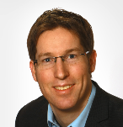
Lars Kuepfer studied chemical engineering at the TH Karlsruhe, RWTH Aachen and Carnegie Mellon University, Pittsburgh, and received his Ph.D. degree in systems biology from ETH Zurich. In 2005, he joined Bayer AG, where he worked on pharmacokinetic and pharmacodynamic modeling of novel drug candidates. In addition, Lars Kuepfer also started as a group leader at the RWTH Aachen in 2011. In 2021, he became professor for systems medicine with focus on organ interactions. Lars Kuepfer’s main research interests are in the areas of physiologically-based pharmacokinetic (PBPK) modelling, systems biology as well as pharmacology and toxicology.

DDI Session

Pradeep Sharma, PhD, is Senior Director, Clinical PBPK Modelling, V&I Group, CPQP, R&D at AstraZeneca with 22 years’ industry experience across DxDMPK, preclinical and clinical DMPK functions in area of clinical pharmacokinetics, PBPK, PKPD, mechanistic modelling, and DMPK sciences. He leads cross-portfolio PBPK strategy, regulatory submissions, and mechanistic modelling for DDIs, special populations, and biologics. He has authored 4 book chapters, 42 peer-reviewed papers, 62 posters, 40 regulatory reports, and delivered 15 invited talks. He has chaired global scientific groups, contributed to industry white papers, and mentored multiple PhD and postgraduate trainees, earning high performance awards internally and externally.


Aki Heikkinen is a Principal Scientist at Certara Predictive Technologies, working remotely from Oulu, Finland since 2022. He contributes to development of the Simcyp Simulator, focusing on metabolism and transporter-mediated drug–drug interactions. He earned his PhD from the University of Eastern Finland in 2010, studying efflux transporters and permeation kinetics. Aki then did a postdoc at Roche in Basel on IVIVE and PBPK of intestinal and hepatic metabolism in humans and dogs. Before joining Certara, he spent eight years at Admescope in Oulu leading services in drug–drug interactions, transporters, and PBPK modeling. He has authored over 30 peer-reviewed publications.
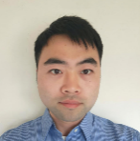
Chen Ning is a PhD candidate at KU Leuven whose research focuses on drug metabolism, transport, drug-drug interactions, and PBPK modeling, with a particular interest in integrated models involving multiple metabolites. His work aims to advance the mechanistic understanding and prediction of pharmacokinetic behavior and interaction potential.

Regulatory “debate” session


Yuching Yang is the team lead of PBPK and QSP team Program, Division of Pharmacometrics, Office of Clinical Pharmacology, Office of Translational Sciences, Food and Drug Administration (FDA). Her primary responsibilities include reviewing PBPK and QSP analysis submitted in IND, NDA and BLA applications and evaluating the MIDD application to support regulatory review, policy implementation and guidance development.


Andrew earned his PhD in Physiology and Pharmacology from the University of Bristol before joining the Medicines and Healthcare products Regulatory Agency (MHRA) in 2023. His initial work focused on evaluating the utility of PBPK modelling in pregnant and lactating women and highlighting critical data gaps in these populations. He now works as a clinical pharmacology assessor at the MHRA and maintains a strong interest in model-based approaches to support safe and effective medicine use in underserved populations.
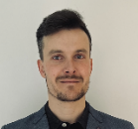
Pieter Colin (Pharm.D., Ph.D.) works as a seconded national expert in the Scientific Advice Office at EMA, providing expertise in Pharmacometrics across the Agency. In addition, he is an Associate Professor at the University Medical Center Groningen (The Netherlands), where he leads a group of (senior) scientists with a focus on treatment individualization in anaesthesia, peri-operative and critical care medicine.

Special Populations Session
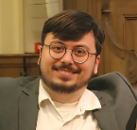
Agustos Ozbey is a pharmacist with a PhD in pharmacokinetic modeling, specializing in mechanistic approaches such as PBPK modeling. He works as a Scientific Specialist in the Non-Clinical Development team at Idorsia, where he applies advanced modeling and simulation (PBPK, PKPD, QSP etc...) strategies to support discovery and early development programs. His work focuses on to characterize drug behavior, guide preclinical candidate selection, and provide robust predictions that inform first-in-human dose selection.

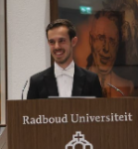
Simon Koele, PhD, is a postdoctoral researcher at Radboudumc in the Netherlands specializing in pharmacological modeling for infectious diseases. His work focuses on physiologically based pharmacokinetic (PBPK) and population pharmacokinetic (popPK) approaches within model-informed drug development. He integrates clinical data and quantitative models across the drug development pipeline, spanning from multinational clinical trials to individualized dosing strategies. By combining pharmacometrics with clinical insight, he aims to better understand drug exposure, variability, and optimal dosing. Simon collaborates with multidisciplinary teams to translate complex modeling results into practical applications that improve antimicrobial therapy and support evidence-based treatment decisions in clinical practice.

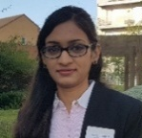
Amita Pansari is a Senior PBPK Consultant at Certara UK Limited, Simcyp Division. She holds a Master’s degree in Pharmacology and has expertise spanning DMPK and modelling and simulation. She began her career at Daiichi Sankyo India, supporting drug discovery through in vitro ADME, IVIVE, PK–PD analysis across multiple DMPK projects. Since joining Simcyp in 2017, she has specialized in PBPK modelling, contributing to the advancement and application of paediatric, pregnancy, and lactation modules. In her current consultancy role, she develops and applies PBPK models to inform regulatory strategies and guide clinical practice, including applications in special populations.

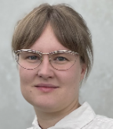
Sophie Fischer-Holzhausen is a Scientist in Systems Pharmacology at ESQlabs. She holds a Master’s in Biophysics from Humboldt University and completed her PhD at the University of Bergen, where she used mathematical modeling to study the endocrine regulation of the human menstrual cycle under the supervision of Prof. Susanna Röblitz. Before joining ESQlabs in 2024, Sophie worked at the University of Bergen, the Norwegian Institute for Public Health, and as a Pharmacometrician at AstraZeneca, gaining expertise in PBPK, QSP, and Population Pharmacokinetic Modeling.


Jiangfan Wu is a doctoral researcher in the Department of Chemistry and Pharmacy at Ludwig-Maximilians-Universität München (LMU), working in the research group of Prof. Scherf-Clavel (see: https://scherf-clavel.cup.uni-muenchen.de/). She holds a master’s degree in clinical pharmacy from China. For the past two years, her research has centered on physiologically based pharmacokinetic (PBPK) modeling. Her current doctoral work focuses on the development and validation of PBPK models for ETI with particular emphasis on model-informed prediction of drug–drug interactions and applications in special populations. Her work aims to advance model-informed drug development and individualized pharmacotherapy.

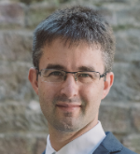
Felix Stader is an Associate Principal Scientist at Certara UK. Following his studies in biology and pharmaceutical science, Felix investigated the impact of advanced age on the pharmacokinetics and drug-drug interaction magnitudes, using a physiologically based pharmacokinetic model coded in Matlab during his PhD. At Certara UK, Felix worked extensively on the biologics models of the Simulator including subcutaneous dosing of therapeutic proteins, oligonucleotides, and the possibility to simulate therapeutic protein disposition in children. Additionally, Felix has broad experience in developing population and compound files.

Biomarkers / Disease


Ahenk Zeynep Sayin earned her bachelor’s degree in Chemical Engineering from Bogazici University, Turkey and her master’s degree in Chemical and Biological Engineering from Koc University, Turkey. She is currently a PhD student at University Hospital Aachen, where her research focuses on physiologically based pharmacokinetic modelling of drug-induced cholestasis. Her doctoral work is conducted in collaboration with Bayer AG and PortaCellTec Biosciences GmbH, integrating experimental and computational approaches to better understand liver toxicity.
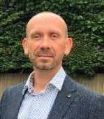
Dr. Simon Teague is Senior Director and Head of PBPK Modelling & Simulation, Drug Discovery, at Pharmaron. He brings over 25 years of experience in Discovery DMPK and PBPK modelling, including two decades at GSK supporting programmes from hit-to-lead through clinical development. His expertise spans multiple therapeutic areas and routes of administration, including pulmonary delivery. His work focuses on human extrapolation and dose prediction to support informed decision making and improve the probability of success in drug development.
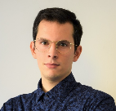
Mattia Berton is a Scientist in the ADME chapter at F. Hoffmann-La Roche. Mattia received his PhD in Clinical Research from the University of Basel. His work at Roche spans from clinical PBPK modeling, with a particular focus on DDI and special populations, to in vitro enzymology and DDI.

Biologics


Howard Burt is a Senior Principal Scientist at Novo Nordisk. Following a PhD and Post-Doc at The University of Manchester, UK, he worked in DMPK groups at Merck Serono and Pfizer Veterinary Medicine. Howard joined Simcyp in 2011, initially within the Translational Science Team, contributing towards the development of drug metabolism and transport related aspects of the Simcyp Simulator. Later, as a Senior Director of PBPK Consultancy he was responsible for the running and regulatory submission of consultancy projects. Howard joined Novo Nordisk in 2024 where he is responsible for establishing PBPK modelling for both small and large molecule projects.

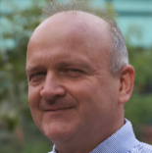
Armin Sepp is Senior Principal Scientist and Head of Biologics Modelling at Certara Ltd. His background is in bioorganic chemistry and a PhD in enzyme kinetics, complemented by postdoctoral training in protein engineering and in vitro antibody evolution at the MRC Laboratory of Molecular Biology in Cambridge. Pharmaceutical career began with human domain antibody engineering at the Domantis Ltd start-up in Cambridge, followed by GlaxoSmithKline, where he became Scientific Leader and GSK Fellow in the DMPK Modelling group. At GSK, he established a quantitative, mechanistic, full-body physiologically-based pharmacokinetic modelling platform for biologics. This supported drug discovery projects for mAbs, antibody fragments and other modalities across diverse therapy areas, ranging from immuno-inflammation to oncology and gene therapy. At Certara, the focus remains on cross-platform/cross-species PBPK modelling of protein therapeutics, but he is also keeping a keen eye on developments in machine learning and quantitative systems pharmacology.


Dr. Erik Sjögren serves as a principal director and the PBPK and PBBM Scientific Lead at Pharmetheus. His research is centered on mechanistic and physiologically based modeling and simulation to support drug development in all phases, adopting techniques such as physiologically based pharmacokinetic (PBPK) modeling, physiologically based biopharmaceutics modeling (PBBM), and quantitative system pharmacology (QSP). In addition to his role at Pharmetheus, he serves as an Associate Professor in Biopharmaceutics at the Department of Pharmaceutical Biosciences at Uppsala University.

Innovative Session


Dr. Bhagwat Prasad is Professor of Pediatrics and Division Director of Translational and Clinical Pharmacology at Cincinnati Children’s Hospital Medical Center. His research focuses on variability in drug disposition and IVIVE of drug transport and metabolism using quantitative proteomics and metabolomics. He directs the PRINCE consortium and previously served as a Tenured Professor at Washington State University. An elected member of the Washington State Academy of Sciences, he has authored over 160 publications and received major honors from ISSX, ASPET, WSU, and ACCP. He trained at NIPER, India and completed postdoctoral work at the University of Washington, Seattle.

Toshiaki Tsuchitani, Ph.D., has been an Assistant Professor at the Faculty of Pharmacy, Keio University (Tokyo, Japan) since 2024. After earning his Ph.D. from Keio University in 2022, he conducted postdoctoral research at the Sugiyama Lab at the iHuman Institute, ShanghaiTech University. His recent PBPK modeling research focuses on leveraging the Cluster-Gauss Newton method (CGNM) to address complex drug disposition mechanisms, such as the biliary excretion of apixaban and the nonlinear pharmacokinetics of telmisartan. Additionally, he works on modeling the endogenous ligand to support efficacious dose prediction in clinical drug development.
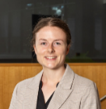
Emily Mannix is a PhD Candidate at the Faculty of Pharmacy and Pharmaceutical Sciences, Monash University. Her research focuses on advancing Virtual Twin approaches within physiologically-based pharmacokinetics, an emerging method of modelling and simulation with transformative potential to support precision dosing and the future of personalised medicine. Emily’s work sits at the intersection of quantitative modelling and clinical practice, focusing on the personalisation of pharmacotherapy to optimise therapeutic outcomes, and advance precision medicine in real-world settings. Emily holds a Bachelor of Pharmacy (Honours) / Master of Pharmacy from Monash University and currently practices as a clinical pharmacist in a metropolitan hospital.


Silvan Käser is a computational chemist and machine learning scientist specializing in data-driven modeling for molecular sciences. He is currently a Roche Postdoctoral Fellow at F. Hoffmann-La Roche in Basel, Switzerland, where he works in early drug discovery. His research focuses on emerging modalities utilizing machine learning and atomistic simulations to predict molecular properties. Silvan holds a PhD in Physical Chemistry from the University of Basel (2024).


Amit is a PhD candidate in Pharmaceutical Sciences at the University of Rhode Island in Dr. Brahim Achour’s lab, where his research focuses on physiologically based pharmacokinetic (PBPK) modeling to study drug exposure in cancer patients and support precision medicine approaches using multi-omics-integrated approaches. He holds a master’s degree in Pharmaceutical Sciences from the University of Toledo, USA, and has over five years of industry experience in pharmaceutical CMC within cGMP environments, contributing to formulation and product development for Phase I–III clinical trials. Amit is passionate about integrating mechanistic modeling with human physiology to inform dosing strategies, predict drug exposure, and advance model-informed drug development. He will be presenting on, “Liquid Biopsy–Informed Systems Pharmacological Framework to Predict Systemic Exposure of Tyrosine Kinase Inhibitors in Leukemia”.

Oral Absorption

Jheniffer Rabelo is a PhD candidate in Pharmaceutical Sciences at the University of São Paulo (FCF-USP). Her research focuses on physiologically based pharmacokinetic (PBPK) modeling, mechanistic drug development, and in silico strategies to support bioequivalence. She works extensively with data extraction, quantitative model integration, and uncertainty analysis, applying Monte Carlo and Bootstrapping simulations within risk-based frameworks guided by Quality by Design (QbD) principles. Her interests include IVIVC development, absorption modeling, and the integration of computational tools to strengthen regulatory decision-making and translational pharmaceutical research.

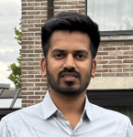
Dr. Harshad Jadhav is a Senior Scientist, Biopharmaceutics at AstraZeneca in Gothenburg, Sweden. He specializes in physiologically based biopharmaceutics modeling (PBBM) for oral drug products using GastroPlus and Simcyp, translating in vitro properties into in vivo performance to inform formulation and clinical decision-making. Harshad earned his PhD in Pharmaceutical Sciences from KU Leuven (Belgium), where he focused on PBBM of colonic drug absorption and extended-release formulations. His expertise includes establishing dissolution safe spaces, supporting bridging strategies, conducting virtual bioequivalence assessments, and evaluating proton-pump inhibitor (PPI) and food effects to de-risk product development and guide study design.


Paul Vrenken is a Consultant at Pharmetheus, where he specializes in model-informed drug development (MIDD) to support client projects. He earned his Master’s in Drug Discovery and Safety from the Vrije Universiteit Amsterdam and attained his PhD from the National and Kapodistrian University of Athens in 2025.
As part of the InPharma Consortium in close collaboration with Bayer, Paul’s doctoral research focused on PBPK and biopharmaceutics modeling of poorly soluble oral drugs. He aims to improve the drug development pipeline by leveraging in silico modeling to minimize animal testing and accelerate clinical timelines.


Julia Macente is a pharmacist and researcher specializing in the application of PBPK modelling and simulation to enhance drug safety and formulation. She earned her Pharmacy degree and her Master’s in Pharmaceutical Sciences from the State University of Maringá , where her research centered on PBPK modelling to evaluate dosing safety in paediatrics population. Dr. Macente completed her PhD at KU Leuven, her doctoral research focused on the development of PBPK models to assess drug exposure within perinatal populations. Currently, she is a Postdoctoral Researcher at Johnson & Johnson within the Biopharmaceutical Sciences. In this role, she focuses on advancing PBPK modelling strategies for amorphous solid dispersions.

Rapid Fire

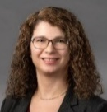
Nada Abla Geiser, PharmD, PhD is Director, PBPK Modelling and Clinical Pharmacology at Medicines for Malaria Venture (Geneva, Switzerland). She worked for 18 years in R&D for neglected and tropical diseases. A pharmacist by training, she obtained her PhD in pharmaceutical sciences from the University of Geneva in 2005, before completing a postdoctoral training in pharmacogenetics at UCSF. Before joining MMV in 2014, she worked for Merck Serono Geneva as laboratory head in DMPK. Her current role at MMV is to lead the PBPK strategy to support antimalarial drug development, in particular for predicting DDIs and PK in special populations.

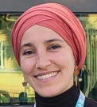
Mariam Mahdjoub, As a pharmacist and toxicologist, I worked in a toxicology laboratory at a university hospital center, focusing on drug monitoring, poisoning cases, and forensic toxicology. I then taught toxicology as an assistant professor in the faculty of pharmacy. Subsequently, I obtained a master's degree in pharmacokinetics. I am currently completing a PhD on toxicokinetics, metabolism, and risk assessment. The objective of this thesis project is to use PBK modeling as a new methodology in the risk assessment of emerging mycotoxins as part of the European project PARC.

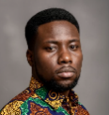
Isaac Mensah is a PhD candidate at the German Federal Institute for Risk Assessment (BfR) in Berlin, where his research focuses on integrating Organ-on-Chip systems and physiologically based kinetic (PBK) models to evaluate low-dose exposure to foodborne toxicants. He holds an MSc in Toxicology from the University of Potsdam, where his thesis compared PBK modeling tools for predicting transdermal absorption and disposition of plant protection products. He is particularly interested in New Approach Methodologies, next-generation risk assessment, and the use of computational and in vitro tools to improve human health protection.

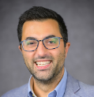
Marco Siccardi is Head of PBPK and Systems Toxicology at ESQlabs. His work focuses on mechanistic modeling to support Model Informed Drug Development and safety assessment. He develops and applies physiologically based pharmacokinetic models and quantitative systems approaches to describe drug disposition, predict drug drug interactions, and understand variability across populations such as pediatrics and pregnancy. His work integrates in vitro data, clinical data, and mechanistic knowledge to translate experimental findings into quantitative predictions of human exposure and biological response. Marco has experience across academia, pharmaceutical research, and CROs, and contributes to open source modeling frameworks used for regulatory and decision making in drug development and chemical risk assessment.


Dr. Dorota Danielak is a Senior R&D Specialist at Physiolution, specializing in integrating biopredictive dissolution testing with mechanistic pharmacokinetic modeling. Her recent work focuses on developing physiologically driven in vitro-in vivo extrapolations using the PhysioCell apparatus to simulate gastric motility and variability. By combining machine learning with population PK simulations, she creates robust models to predict the performance of complex oral dosage forms. A Ph.D. graduate of Poznan University of Medical Sciences, an experienced academic teacher, and a participant in EU-funded research programmes, Dr. Danielak was a speaker at global forums such as AAPS PharmSci360, contributing to the advancement of virtual bioequivalence and biopharmaceutics.
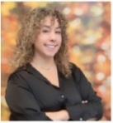
Sara Peribañez, AstraZeneca. Graduate in Pharmacy from the Complutense University of Madrid. After completing a Master’s in Drug Research, Development and Innovation, at the University of Navarra, she pursued a PhD in the Medicines and Health program titled “Optimizing Oncolytic Viral Therapeutics through Development of Predictive Computational Models.” She currently works at AstraZeneca as an Associate Clinical PBPK Modeler, supporting multiple therapeutic areas and leading projects on drug–drug interactions (DDIs), special populations, and organ impairment, among others.

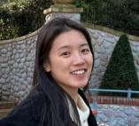
Jimeng Wu "I am a PhD researcher working on physiologically based pharmacokinetic (PBPK) modeling and quantitative approaches for translational risk and dose assessment. My research focuses on integrating in vitro and in silico methods to predict biodistribution, exposure, and organism-level responses for chemicals and advanced materials, particularly nanoparticles. I also contributed to translational PBPK modeling for cell therapies, including CAR-T, to support first-in-human dose selection. My work combines mechanistic modeling, machine learning, and quantitative risk assessment to advance predictive, human-relevant approaches for safer and more sustainable development in biomedical, chemical, and environmental applications."


Justine Henriot, PharmD, graduated as a pharmacist and completed a MSc in pharmacokinetic modeling in France in 2023. Her modeling expertise focuses on PBPK with previous experience in drug-drug interactions and gastrointestinal metabolism of small molecules. She is currently pursuing a PhD at the Belgian Nuclear Research Center (SCK CEN) and KU Leuven, focusing on PBPK modeling of [¹⁷⁷Lu]Lu-DOTATATE and [¹⁶¹Tb]Tb-DOTATATE targeted radiopharmaceutical therapies of neuroendocrine tumors. Her work bridges preclinical experiments, clinical studies and computational modeling to optimize and personalize therapies. Passionate about translational research, she aims to advance predictive tools that support clinical decision-making and the development of next-generation therapeutics.
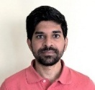
Dr. Gaurangkumar Patel is a Senior Research Scientist at Certara Predictive Technologies working with focus on absorption modelling of oral drug products. He contributes to development of the PBPK models for biopharmaceutics applications including analysis of in vitro experimental data and virtual bioequivalence. Prior to joining Certara, he worked with pharmaceutical companies like Mylan (now Viatris) and Amneal for around 5 years gaining experience in biopharmaceutical development of complex generic and hybrid NDA products contributing to preclinical and clinical development.
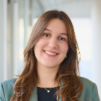
Ines is a recent Master’s graduate in Chemistry from ETH Zürich and is currently pursuing her internship in the ADME chapter at F. Hoffmann-La Roche. Her research focuses on enhancing the in vitro-in vivo translatability of time-dependent inhibition (TDI) predictions for the cytochrome P450 enzymes 2C9 and 2D6 through the application of improved in vitro methodologies and PBPK modeling.
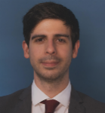
Carmine Schiavone is a Scientist in Systems Pharmacology at ESQlabs, where he develops mechanistic PBPK and QSP models for complex biologics, including bispecific antibodies. He completed his PhD through a joint program between the University of Naples Federico II and Houston Methodist Research Institute, focusing on using PBPK and QSP modeling to predict immune responses and guide vaccine design.
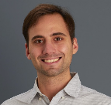
Dr. Maximo Pettarin is a pharmacist specializing in physiologically based biopharmaceutics modeling (PBBM) and the development of biorelevant in vitro dissolution testing methods. He has broad expertise in biopharmaceutics, pharmacokinetics, and in vitro–in silico integration to support model-informed drug development and decision-making across R&D. During his doctoral research at Goethe University Frankfurt, he developed innovative dissolution media and mechanistic PBBM models for challenging BCS II/IV compounds. At Sanofi and now Simulations Plus, he applies computational modeling, software development, data science, and machine learning to support drug development in collaboration with industrial and regulatory partners.

